**Academic Year 2023-24**



**MAHARASHTRA STATE BOARD OF TECHNICAL EDUCATION, (MUMBAI)**

**A**

**Project Report**

**on**

**“Attendance Monitoring System using Facial Recognition”**

***Submitted by:***

|  |  |  |
| --- | --- | --- |
| **Sr. No.** | **Name of Student** | **Exam Seat No.** |
| **1)** | **Aditya Suryawanshi** | **:____________** |
| **2)** | **Sejal Pathak** | **:____________** |
| **3)** | **Sakina Modi** | **:____________** |

***Under the Guidance of:***

**Name of Guide:Mr._Sunil .H. Sangale**

**Designation : Lecturer in Computer Technology**



**Department of Computer Technology**

**K. K. WAGH POLYTECHNIC, NASHIK**

**Academic Year 2023-24**

KarmaveerKakasahebWagh Education Society’s

**K. K. WAGH POLYTECHNIC**

HirabaiHaridasVidyanagari, Amrutdham, Panchavati, Nashik-422003, Maharastra

|  |  |  |
| --- | --- | --- |
|  |  |  |

This is to certify that 1) Aditya Suryawanshi, 2) Sejal Pathak, 3) Sakina Modi

From K.K.Wagh Polytechnic,Nashik has completed Report on the Semester Vth Project Report having title Attendance Monitoring System Using Facial Recognition in a group consisting of 3 persons under the guidance of Mr.S.H.Sangale.

Mr.S.H.Sangale Prof.G. B. Katkade

Internal Guide HOD- Computer Tecnology

Prof. P. T. Kadave

Principal

#### **acknowledgement**

With deep sense of gratitude we would like to thanks all the people who have lit our path with their kind guidance. We are very grateful to these intellectuals who did their best to help during our project work.

It is our proud privilege to express deep sense of gratitude to,Prof. P. T. Kadave, Principal, K.K.Wagh Polytechnic, Nashik for his comments and kind permission to complete this project. We remain indebted to Prof. G.B. Katkade, Head ofComputer Technology Department for his timely suggestion and valuable guidance.

The special gratitude goes Internal Guide **Mr.Sunil .H. Sangale,** staff members, technical staff members, of Computer Technology Department for his expensive, excellent and precious guidance in completion of this work. We thanks to all the class colleagues for their appreciable help for our working project.

With various industry owners or lab technicians to help, it has been our endeavor to through out our work to cover the entire project work.

We also thankful to our parents for providing their wishful support for our project completion successfully.Lastly we thanks to our all friends and the people who are directly or indirectly related to our project work.

Names of Students

1) Kapil Pardeshi class: TYCM-WIN

2) Archit Bhandare class: TYCM-WIN

3) Susheel Deokar class: TYCM-WIN

**ABSTRACT**

In today's educational landscape, ensuring the regularity of student attendance remains a paramount concern, even in the face of unprecedented challenges such as the COVID-19 pandemic. Traditional methods of marking attendance, such as roll call and paper signatures, have proven to be time-consuming and cumbersome. Recognizing the need for a more efficient and eco-friendly solution, we have embarked on a project to develop an "Attendance Monitoring System Using Facial Recognition" using Android Studio and TensorFlow.

Our innovative application harnesses the power of face identification, not only streamlining the attendance tracking process but also contributing to environmental sustainability by reducing paper usage. Moreover, it addresses the persistent issue of fake attendance by employing facial recognition as a biometric authentication method. This system is tailored for educational institutions where accurate attendance monitoring is of paramount importance.

The proposed system, designed for the Android platform and powered by TensorFlow's machine learning library, relies on sophisticated algorithms that compare encoded facial values from a database with real-time images captured by the system. This project represents a leap forward in attendance management, aligning technology with educational needs. By automating attendance and enhancing accuracy, it promises to make a significant impact on the educational landscape.

**Table of Contents**

|  |  |
| --- | --- |
| **Sr.No.** | **Name of topic** |
| 1 | Abstract, Table Index, Figure Index, Acknowledgement, Certificates, |
| 2 | Introduction |
| 3 | Literature Survey |
| 4 | Project Requirement Analysis & Feasibility |
| 5 | Project Design & Analysis |
| 6 | Conclusion and Feature Scope |
| 7 | References / Bibliography |

**CHAPTER 1 Introduction**

The Attendance System using Face – Recognition is a replacement way method for the traditional way of marking attendance. The proposed system is Android, Machine Learning based system.. This system can be implemented on a single faculty system of a particular institute. This system is proposed to be based on biometrics .i.e. Face Authentication. Since there is presence of biometrics, this system completely eliminates the chances of fake attendance which is a problem with the traditional methods of attendance.

The Attendance management is the significant process that were carry out in every institute to monitor the performance of the student. Every institute does this in its own way. Some of there institute use the old paper or file-based system and some have adopted strategies of automated attendance system using some biometric technique. A facial recognition system is a computerized software which is suited for determining or validating a person by performing comparisons on patterns based on their facial appearances.

Here, the teacher will be the super user (Administrator). Teacher will be able to manage the data of the students stored in the database. Data includes attendance, performance in practicals, rating of student,etc. After the completion of theory sessions the teacher would just scan multiple students and assign the attendance of present students in just one tap! Administrator would also be able to scan the face of a particular student and read its data.

**CHAPTER 2 Literature Survey**

Using real time computer vision algorithms in automatic attendance management systems This system introduces a new approach in automatic attendance management systems, extended with computer vision algorithms. The Proposed system uses real time face detection algorithms.

Automatic Control of students’ attendance in Classrooms Using RFID Radio frequency identification (RFID) is one of the automatic identification technologies more in vogue nowadays. There is a wide research and development in this area trying to take maximum advantage of this technology, and in coming years many new applications and research areas will continue to appear.

Face Recognition based Attendance Management System using Machine Learning is the most arduous task in any organization is attendance marking. We proposed an automated attendance management system which tackles the predicament of recognition of faces in biometric systems subject to different real time scenarios such as illumination, rotation and scaling.

Face Recognition-based Lecture Attendance System proposed a system that takes the attendance of students for classroom lecture. The system takes attendance automatically using face recognition. However, it is difficult to estimate the attendance precisely using each result of face recognition independently because the face detection rate is not sufficiently high.

**CHAPTER 3 Project Requirement Analysis and Feasibility**

**Requirement Analysis:**

**1.1 Purpose:**

The purpose of this project is to develop an "Automated Attendance System Based on Face Recognition" to address the challenges associated with traditional methods of attendance tracking in educational institutions. The system aims to provide an efficient and eco-friendly solution by automating attendance while eliminating the risk of fake attendance.

**1.2 Functional Requirements:**

* Real-time face detection for attendance marking.
* Face recognition with a minimum accuracy of 98%.
* Database to store student information and attendance records.
* User authentication and authorization for teachers and students.
* Emergency stop feature for system security.
* Data encryption for privacy protection.
* Reporting and analytics for performance analysis.

**1.3 Non-Functional Requirements:**

* Usability: The system should be user-friendly.
* Reliability: The system should have a minimum uptime of 99.9%.
* Maintainability: Updates and maintenance should cause minimal downtime.
* Portability: Support for Android versions from 6.0 and above.
* Testability: Test cases should cover at least 95% of the system's functionality.
* Interoperability: Integration with third-party educational tools.
* Security: Strong user authentication, data encryption, and access control.
* Privacy: Compliance with data privacy regulations (e.g., GDPR).

**Feasibility Analysis**

**2.1 Technical Feasibility:**

The project requires expertise in Android app development and TensorFlow machine learning.

The technical team should be skilled in image processing and database management.

Access to suitable hardware and software tools for development is necessary.

**2.2 Economic Feasibility:**

The project budget should cover development costs, hardware and software expenses, and ongoing maintenance.

Economic feasibility will depend on the cost-effectiveness of the solution compared to traditional attendance methods.

**2.3 Operational Feasibility:**

Training for teachers and administrators to use the system effectively.

A seamless integration process with the existing educational environment.

**2.4 Schedule Feasibility:**

The project timeline should allow for development, testing, and implementation.

Adherence to a realistic schedule is crucial to meet the demands of educational institutions.

**CHAPTER 4 Project Design and Analysis**

**Context Level Diagram for facial recognition**

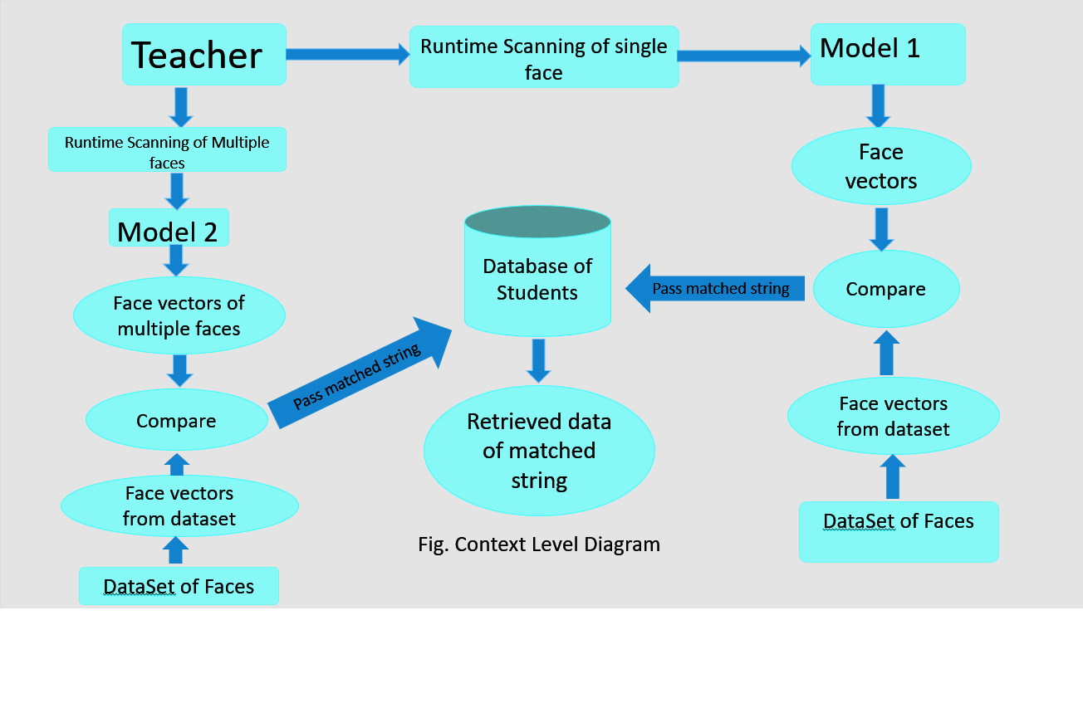

The teacher is the administrator of the system. Two models are trained for facial recognition. (Model 1 & Model 2). There will be two operations performed by the admin:

1. **Scanning a single face:**

When a single face is to be scanned, Model 1 will be used which will scan the face and generate face vectors like face embeddings, encodings, convert from BGR2GRAY, etc. Then those face vectors will be compared with the ones from dataset of faces. If the faces match then respective data of the student will be retrieved from the database.

1. **Scanning multiple faces:**

When multiple faces are to be scanned, Model 2 will be used which will scan the faces and generate face vectors like face embeddings, encodings, convert from BGR2GRAY, etc. Then those face vectors of multiple faces will be compared with the ones from dataset of faces. If the faces match then respective data of the student will be retrieved from the database.

**E-R Diagram**



**Data Flow Diagram**



**DFD (Level 0):**

In the Level 0 Data Flow Diagram (DFD) for the Student Attendance Management System using face recognition, the system is depicted as the central hub through which data flows between two primary actors: the teacher and the student. On the left side of the diagram, we have the teacher, who serves as the administrator and data manager. The teacher's role involves managing student data, which includes performance records and ratings. On the right side of the diagram, we have the student, who interacts directly with the system to mark their attendance using the face recognition feature.

**DFD(Level 1):**

The "Login Check Process" is responsible for verifying user login credentials, ensuring secure access to the system. Once logged in, users can interact with the system, with their actions being recorded and processed in the "Database (Student Information)." This component stores and manages student data. Meanwhile, the "Logout Process" offers users a secure way to exit the system when their interactions are complete.

**UML Diagram (Activity Diagram)**



The image (dynamic frames) will be loaded from the camera view then passed for detection, if faces are present then after detection they’ll be cropped, and dataset will be generated. Training of the database will be carried out (using python). Once the model is trained, it’ll be ready for facial recognition tasks. Input frames from runtime scanning will be provided to the model and students whose faces are detected will be marked as present.

**Module Analysis & designs**

1. **User Authentication Module:**

* Module Title/Name: User Authentication
* Purpose of Module: To authenticate and authorize users (teachers).
* Inputs: User credentials (username and password).
* Outputs: Authentication success or failure.
* Files Used: User database for authentication.
* Algorithm/Procedural Steps:
  + Receive user credentials.
  + Verify credentials against the user database.
  + Grant or deny access based on verification.

**2) Face Recognition Module:**

* Module Title/Name: Face Recognition
* Purpose of Module: To compare detected faces with stored student faces.
* Inputs: Detected face coordinates, student database.
* Outputs: Matched student ID or unknown face.
* Files Used: Student face database for comparison.
* Algorithm/Procedural Steps:
* Receive detected face coordinates.
* Compare the face with the faces in the database.
* Return the matched student ID or mark as an unknown face.

**3) Attendance Recording Module:**

* Module Title/Name: Attendance Recording
* Purpose of Module: To mark attendance and store attendance records.
* Inputs: Matched student IDs from the Face Recognition module.
* Outputs: Attendance records.
* Files Used: Attendance database for storage.
* Algorithm/Procedural Steps:
  + Receive matched student IDs.
  + Mark attendance for identified students.
  + Store attendance records in the database.

**User Interface Designs**

**Login page:**

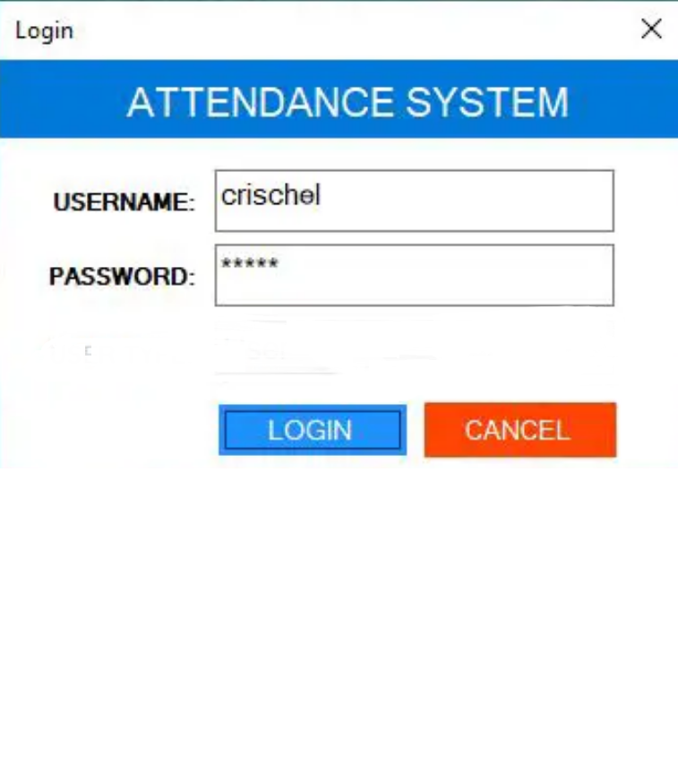

**Home Page:**

Check Database

Mark attendance

Scan a face

**CHAPTER 5 Conclusion and Feature Scope**

**Conclusion:**

The "Attendance Monitoring System using Facial Recognition" project presents an innovative and efficient solution to the perennial challenges faced by educational institutions when it comes to monitoring and recording student attendance. By leveraging cutting-edge technology and machine learning capabilities, this system not only streamlines attendance tracking but also enhances security and reduces environmental impact.

Through our feasibility analysis, we have determined that this project is both technically and economically feasible. The benefits of implementing this system include improved accuracy, reduced administrative workload, and a positive impact on the environment by minimizing paper usage.

It’s important to emphasize that the successful development and implementation of this system will significantly contribute to educational institutions' operational efficiency and effectiveness. It aligns with the ever-evolving educational landscape, providing a robust solution to the persistent issue of attendance management.

**Feature Scope:**

* **User Authentication:** Implement user authentication to ensure secure access for teachers, students, and administrators.
* **Real-Time Face Detection:** Utilize real-time face detection to identify students in class.
* **Face Recognition:** Employ facial recognition to verify the identity of students and mark their attendance.
* **Database Management:** Maintain a well-structured database for storing student information and attendance records.
* **Security and Privacy:** Ensure data security and privacy compliance with encryption, access control, and data anonymization.
* **Reporting and Analytics:** Provide reporting and analytics features for teachers and administrators to analyze attendance and student performance data.
* **Mobile Application:** Develop a user-friendly mobile application for Android, making the system accessible to a wide range of users.

**CHAPTER 6 References and Bibliography**

[1]. Dipti Kumbhar , Prof. Dr. Y. S. Angal Department of Electronics and Telecommunication, Smart Attendance System using Computer Vision and Machine Learning yogeshangal@yahoo.co.in IRJET 1/4/2022]

[2]. P. Visalakshi, Sushant Ashish Assistant Professor ,Department of Computer Science and Engineering SRM Institute of Science and Technology, Chennai, Tamil Nadu, ATTENDANCE SYSTEM USING MULTI-FACE RECOGNITION , IEEE 27/5/2023]

[3]. CH. VINOD KUMAR , DR. K. RAJA KUMAR PG Scholar, Dept of CS& SE, Andhra University, Vishakhapatnam, AP, India. Assistant Professor, Dept of CS& SE, Andhra University, Vishakhapatnam, AP, India. Face Recognition Based Student Attendance System with OpenCV 15/12/2022]

[4]. Face Recognition based Attendance Management System using Machine Learning. IRJET 06, June 2022 ]

[5]. Ashish Choudhary,Abhishek Tripathi,Abhishek Bajaj,Mudit Rathi and B.M Nandini Information Science and Engineering, The National Institute of Engineering, Automatic Attendance System Using Face Recognition. IRJET 12/5/2021]

[6]. Anushka Waingankar1, Akash Upadhyay, Ruchi Shah, Nevil Pooniwala, Prashant Kasambe. Face Recognition based Attendance Management System using Machine Learning IEEE 8/6/2023]